|  |  |  |
| --- | --- | --- |
|  |  |  |

**Chapter 1**

**Introduction**

* 1. **Introduction**

Apparently in our today world things cannot be done organized, accurately and efficiently using file-based system so making things globally in a digitized way is a tremendous advantage in especially this type of Attendance management system program.[1] The purpose of developing this attendance management system is to computerized the tradition way of taking attendance. Another purpose for developing this system is to generate the report automatically at the end of the semester.[1]

* 1. **Background of Project**

Currently the result system of BAUET works in way that the teacher takes the attendance of the students manually by using a excel sheet or by using a paper sheet. In both the system the teacher has to manually check if all the students are present in the class room and it takes a lot of time to check if all the students are present in the class and sometimes error can happen like sometime a student can give proxy of another student which will be counted as a true present unless the teacher spends a lot of time checking if the no of students present are equal to the number of student present in the sheet. As you can see from this that this process takes a lot of time to do the accurate calculation of the number of student present in the class. This is a problem because it wastes both time of the student and the teacher. If we can save the time of the teacher and students then they can utilize the time with their research and studies. Another problem with manual attendance management is that this data can be manipulated by someone and in most of the cases this data cannot be used for other purposes. Because the data is not kept for long period of time or is hard to find any record of the attendance in long period of times. All of this problems call be solved using a digital attendance management system so it will be easier to manage these kinds of data and it will be kept safe for future uses of the data.

By examining the problems mention in above we can clearly see that the Smart Attendance System is very necessary for BAUET.

enables the faculty to record, store, and monitor students' attendance history & manage the classroom efficiently. The automatic attendance system is designed & developed to record students' attendance.

**1.3 Objectives**

(i) For reliable Accuracy.

(ii) To eliminate duplicate data entry and errors in time.

(iii) To track the attendance of teachers and staff, assign work and manage allocation.

(iv) To auto-generate various types of reports of class or student attendance.

(v) To enhance Student Performance.

(vi) Get instant Notification to Parents.

**1.4 Conclusion**

Student attendance system helps teachers to mark online attendance of students during class & reduce manual work. It is used to track student's attendance, absentee record, attendance history & other related documents. Student attendance software allows you to record & manage daily student attendance to speed up the daily attendance process.

**Chapter 2**

**Planning**

**2.1 Introduction**

This system developed will reduce the manual work and avoid redundant data. By maintaining the attendance manually, then efficient reports cannot be generated. The system can generate efficient weekly, consolidate report based on the attendance. As the attendances are maintained in registers it has been a tough task for admin and staff to maintain for long time. Instead, the software can keep long and retrieve the information when needed.

# **2.2 Scope of the work**

The project has a very vast scope in future. The project can be implemented on intranet in future. Project can be updated in near future as and when requirement for the same arises, as it is very flexible in terms of expansion. With the proposed software of database Space Manager ready and fully functional the client is now able to manage and hence run the entire work in a much better, accurate and error free manner. The following are the future scope for the project.

* Discontinue of particular student eliminate potential attendance.
* Bar code Reader based attendance system.
* Individual Attendance system with photo using Student login.

# **Methodology:**

Step 1: At first, we have to enter this website.

Step 2: For entering this website we have to registration here.

Step 3: For completing our registration, we can see attendance home page.

Step 4: We can add student and add department also.

Step 5: Then we will get access data. And also take the attendance and see who is ­­_______absent or present.

**2.4 Flowchart**

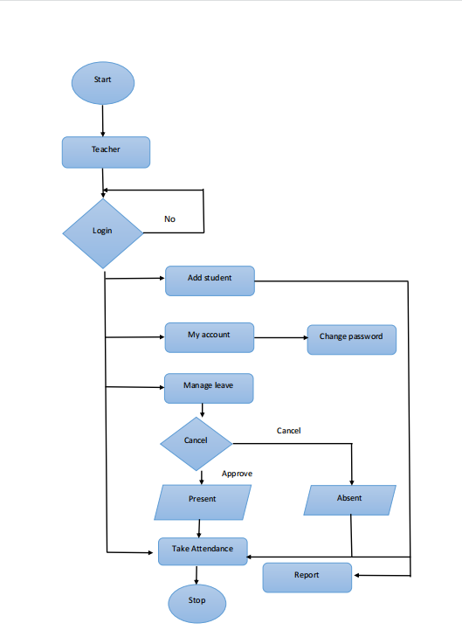

**Figure-01:** Flowchart for smart attendance system

**2.5 Conclusion**

Now people are using technologies for diverse purposes. The student’s attendance management are seeing for the scope to elevate their daily actions. These systems are an exigent part of any successful business and is materially used to efficiently track inventory using both hardware and software.

**Chapter 3**

**Analysis**

**3.1 Introduction**

An attendance management system refers to an organization's approach to tracking employee time and attendance information. An accurate attendance and time tracking system helps you save time and effort in calculating your employees' working hour. Student attendance system helps teachers to mark online attendance of students during class & reduce manual work. It is used to track student's attendance, absentee record, attendance history & other related documents. Below are the questions that we asked them and the following answers.

**3.2 Analysis Report**

**Information Provider’s Name:** Aroni Saha Prapty (Lecturer, Dept. of CSE, BAUET)

**Question 1: What attendance system does BAUET follow?**

**Ans:** BAUET has strict rules regarding the issues of attendance in class and discipline:

Attendance: Following guidelines are to be adjusted to:

a. All students are required to attend 80% of the classes for all courses.

b. In case of sickness 70% attendance may be considered by the VC with proper medical documents provided by the student.

c. Students failing to attend 80% classes are liable to pay a fine of Tk. 2000/- per course.

d. Students not eligible to sit for exam of a particular course due to poor attendance, their concerned course will be deleted form the Admit Card.

e. A student will not be entitled to Vice Chancellor or the Dean’s list of the Semester, in case he/she has not attended 90% if the classes. S/he will also not be considered for any Scholarship/Waiver provide by the University.

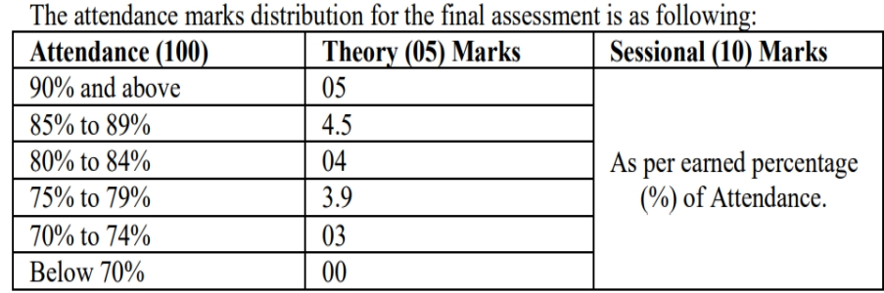

**Information Provider’s Name:** Subrata Kumer Paul (Lecturer, Dept. of CSE, BAUET)

**Question 2: What is the problem with attendance now?**

**Ans:** There are a lot of problems when doing bookkeeping with a pen. Sometimes there is a problem with calculations and there is fear of getting lost. In today's age, everything is digital. It has infinite role in education. Earlier, teachers used to come to the class with pen in hand to see if they are present or not because of the fear of losing the papers. But in today's era this is no more. Everything is going digital so we want to make smart attendance system which will contribute a lot in the field of education. The problem with existing system is that the manual system is time consuming and the advanced technologies are too expensive to be implemented on a large scale in any organization. The following system eliminates the tedious task of manually maintaining the attendance records by automating it.

**Information Provider’s Name:** Subrata Kumer Paul (Lecturer, Dept. of CSE, BAUET)

**Question 3: If we do this in our project, will you benefit?**

**Ans:** A teacher can view the student profile and see that which days are present and which days are absent.

**Information Provider’s Name:** Subrata Kumer Paul (Lecturer, Dept. of CSE, BAUET)

**Question 4: What updates are good for you?**

**Ans:** There will be complete information about non collegiate/collegiate and a student. Attendance 70% is called non collegiate and 80% is called is called collegiate. This information views a teacher and sending a mail.

**Information Provider’s Name:** Redoanul Hoque (Lecturer, Dept. of CSE, BAUET)

**Question 5: What updates are good for you?**

**Ans:** He said, it would be nice to see some more animations. It will be nice system if we build it successful and it will help for the teacher and save their time.

**Information Provider’s Name:** Md. Arik Rayhan (CSE 11th batch, BAUET)

**Question 6: What updates are good for you?**

**Ans:** He said that he should see here which class he was not in or what is his total percentage.

**Information Provider’s Name:** Most. Jannatun Ferdous (CSE 11th batch, BAUET)

**Question 7: What updates are good for you?**

**Ans:** She is benefited for our system. She said that we need to have good backup of our system so that we can have things as backup in case of software problems.

**3.3 Conclusion**

Tracking student attendance helps the teachers to keep track of student absenteeism and punctuality. It helps schools understand the average percentage of students attending school each day in the given year and helps them find ways to avoid dropouts.

**Chapter 4**

**Design**

**4.1 Introduction**

Input design is part of overall system design that requires special attention designing input data is to make the data entered easy and free from errors. The input forms are designed using the controls available in NET framework. Validation is made for each and every data that is entered. Help information is provided for the users during when the customer feels difficult. Input design is the process of converting the user originated inputs to a computer based format. A system user interacting through a workstation must be able to tell the system whether to accept the input to produce reports. The collection of input data is considered to be most expensive part of the system design. Since the input has to be planned in such a manner so as to get relevant information, extreme care is taken to obtain pertinent information. This project first will enter to the input of allocation forms it will be created on student details form and subject entry form, time table form .it will helps to calculate subject wise attendance system. next one if u want any verification on your date's also available in details show forms. Attendance to entered single subject wise or all subject wise attendance system available in this project. Output design this application “Smart Attendance system “generally refers to the results and information that are generated by the system for many end-users; output is the main reason for developing the system and the basis on which they evaluate the usefulness of the application.The output is designed in such a way that it is attractive, convenient and informative. Forms are designed with various features, which make the console output more pleasing. As the outputs are the most important sources of information to the users, better design should improve the system’s relationships with us and also will help in decision making. Form design elaborates the way output is presented and the layout available for capturing information. One of the most important factors of the system is the output it produces. This system refers to the results and information generated. Basically, the output from a computer system is used to communicate the result of processing to the user. Attendance management system to show the report subject wise attendance maintaining by staffs. Taken as a whole report obtain on a administrator privileges only this forms will show weekly report and consolidate report generated date, batch, andclass wise to our end user. we want to change our report to convert Excel format. if you want change any modification.

**4.2 Use Case Diagram**

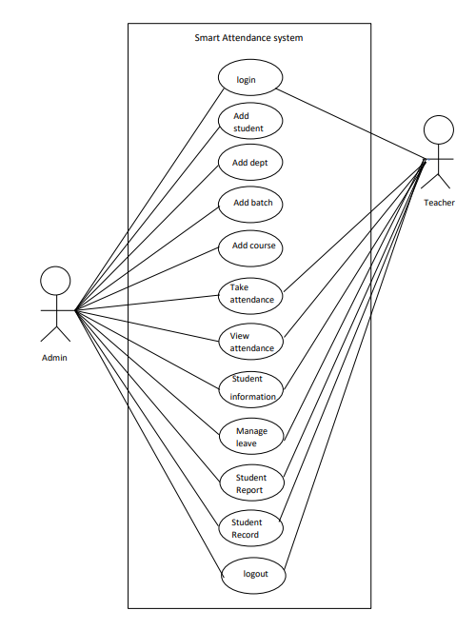

**Figure-02:** Use Case Diagram for smart attendance system

use-case diagrams describe the high-level functions and scope of a system. our project has two actor’s admin and a teacher. Here admin can access all features like login, add student, add dept, add batch, add a course, take attendance, view attendance, student information, manage to leave, student report, student record, logout. Teachers can access some features like login, take attendance, view attendance, student information, manage to leave, student report, student record, and logout.

**4.3 UML Diagram**

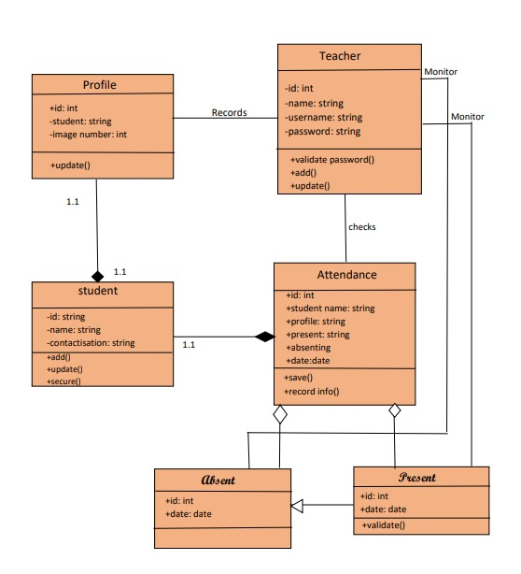

**Figure-03:** UML Diagram for smart attendance system

A UML diagram is a diagram based on the UML (Unified Modelling Language) to visually represent a system along with its main actors, roles, actions, artefacts or classes, to better understand, alter, maintain, or document information about the system. UML has been used as a general-purpose modelling language in the field of software engineering. our project name is a smart attendance system. Our project has some relationship between one object to another object. profile and student relation between composition. student and attendance relationship between composition. attendance and absent/present relationship between aggregate. The absent and present relationship between abstract.

**4.4 Conclusion**

Student attendance system helps teachers to mark online attendance of students during class & reduce manual work. It is used to track student's attendance, absentee record, attendance history & other related documents. Student attendance software allows you to record & manage daily student attendance to speed up the daily attendance process.

**Chapter 5**

**Implementation**

**5.1 Introduction**

An attendance management system refers to an organization's approach to tracking employee time and attendance information. An accurate attendance and time tracking system helps you save time and effort in calculating your employees' working hours.

**5.2 Screenshot**

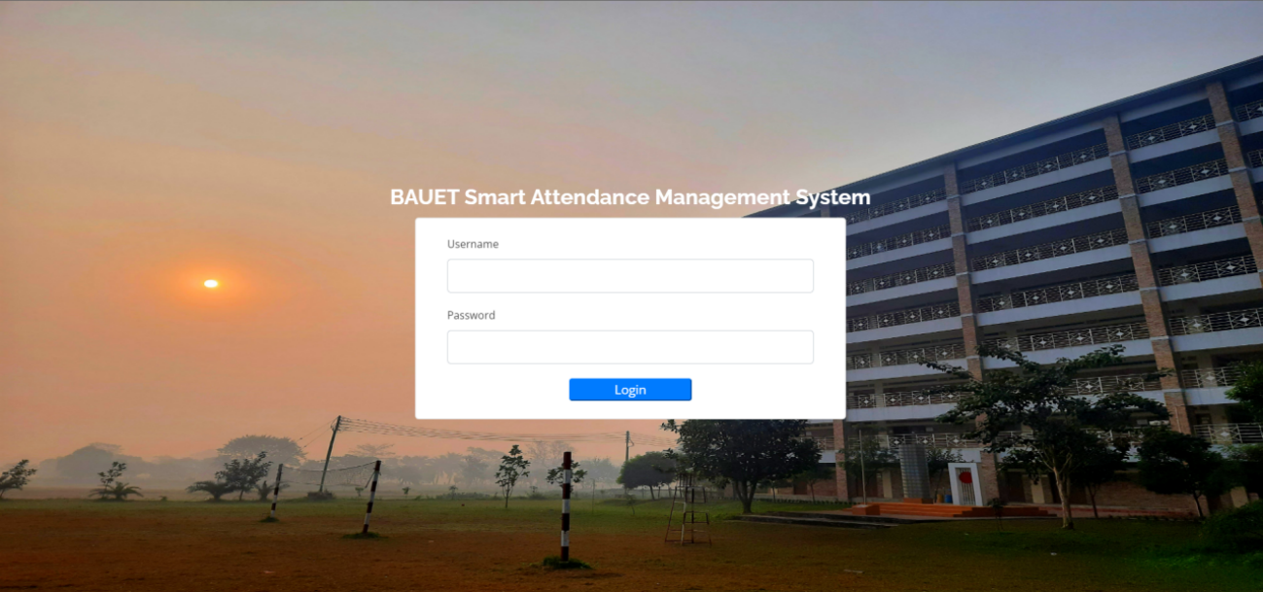

**Figure-04:** Login Page

Here Users and admin can access the system with their username and password. If the username and password does not match users can’t login the system.

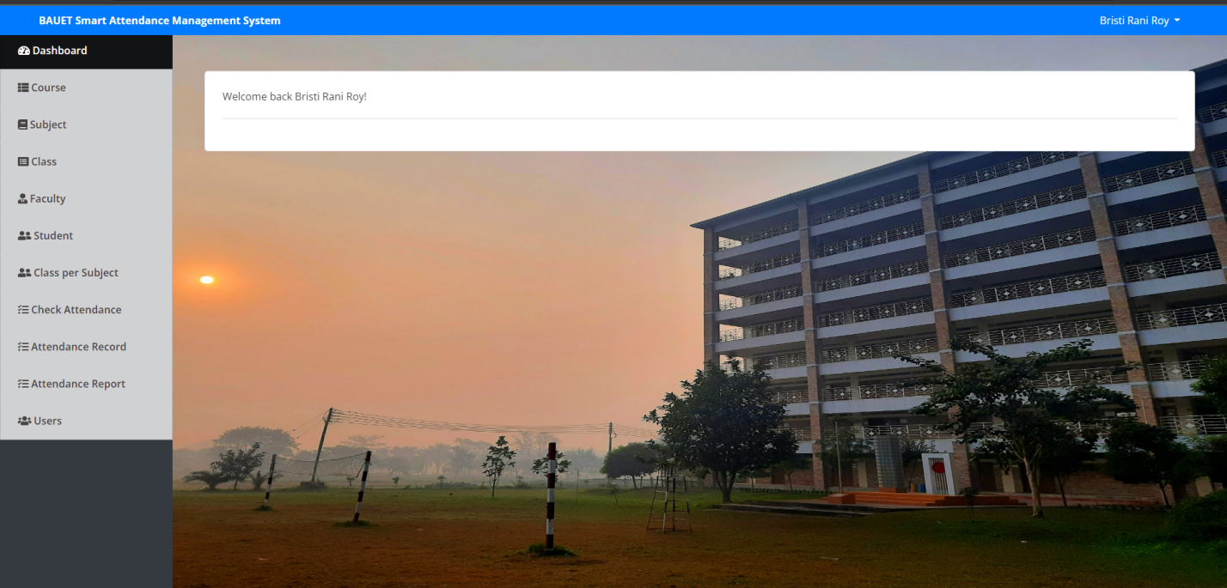 **Figure-05:** Welcome Page for Admin

With login with username and password they can see the welcome page and dashboard and choose the option. This page only see the Admin who access the full system.

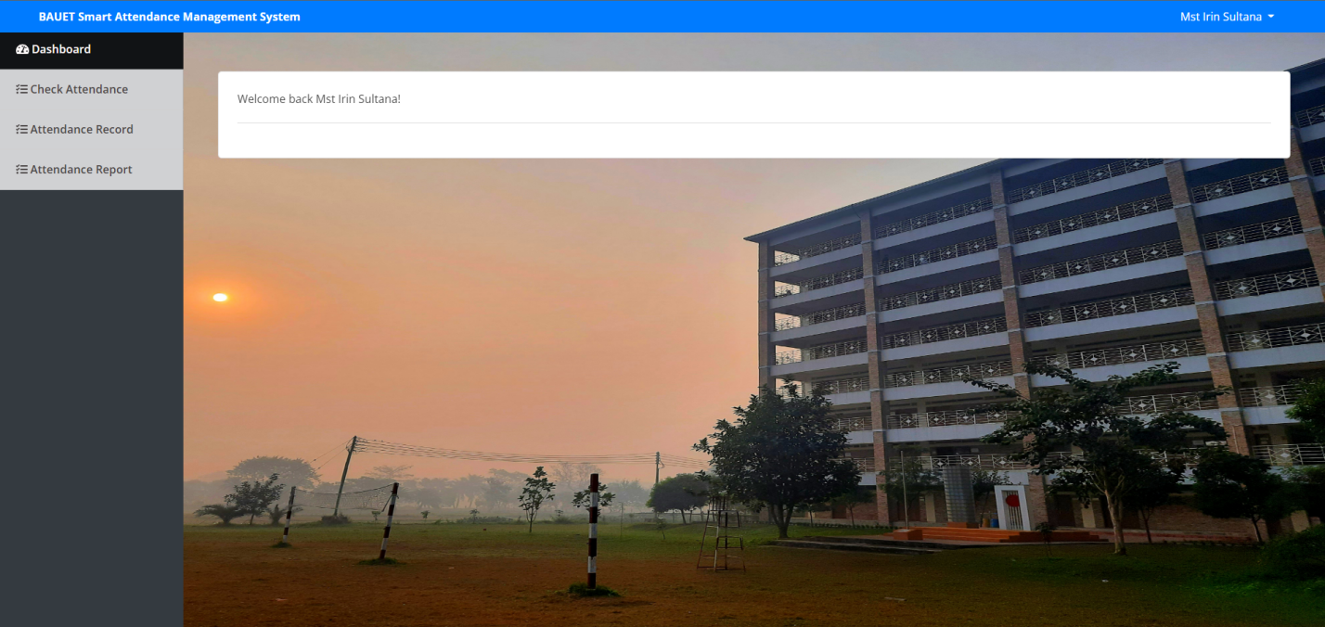

**Figure-06:** Welcome Page for Teacher

With login with username and password they can see the welcome page and dashboard and choose the option. This page only sees the teacher who access the system.

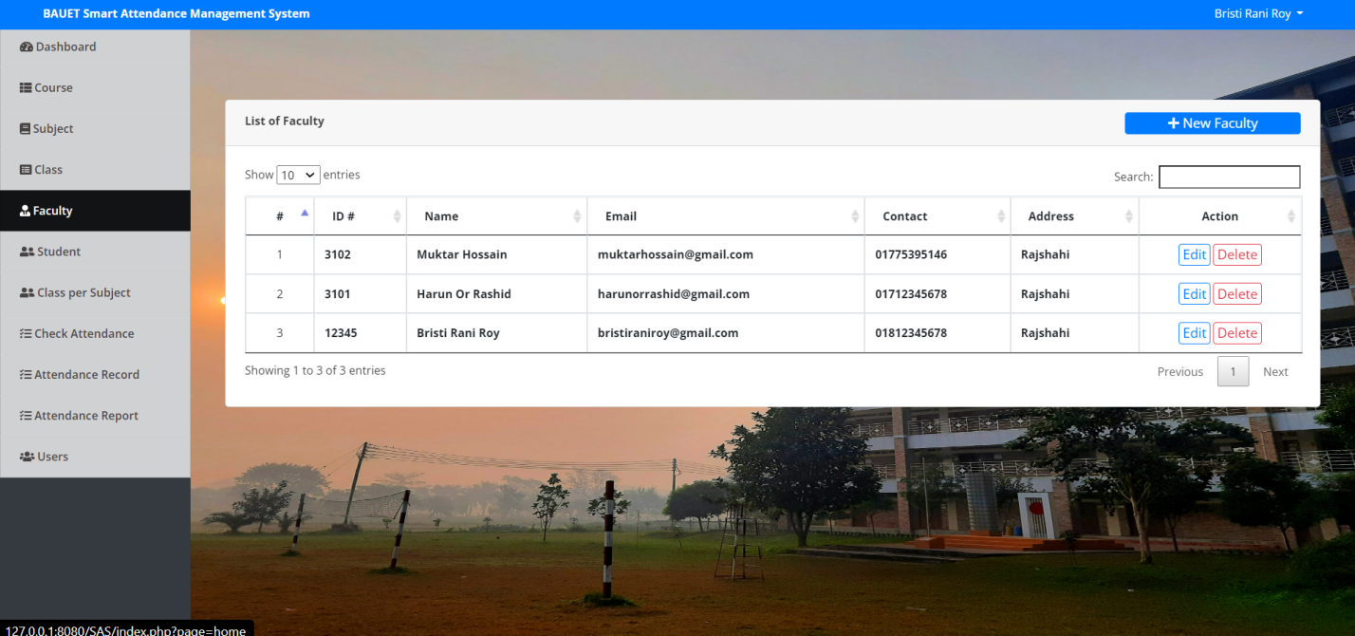

**Figure-07:** Add Faculty

Here Admin add the new Faculty member. In New Faculty member option, they click see the Form and fill-up the form. After fill upping, he or she will be faculty member.

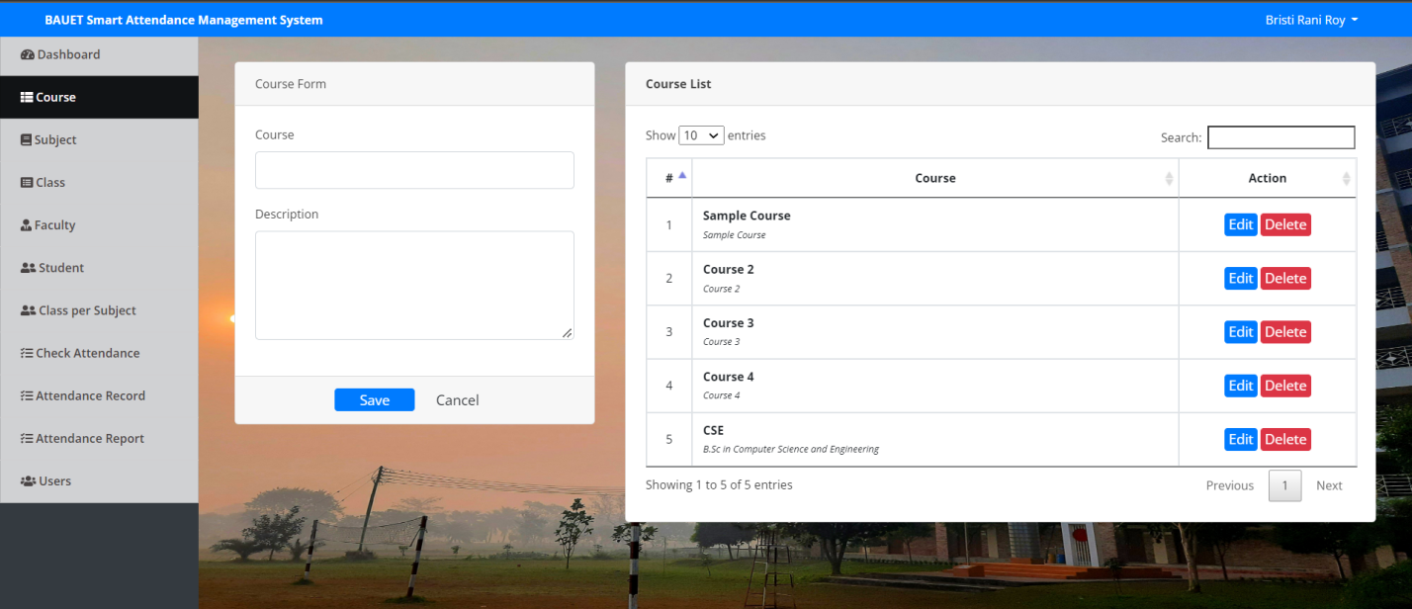**Figure-08:** Add Course

Here Admin can add course. Admin can access the course and fill up the form for new

courses. And beside he can see the course list.

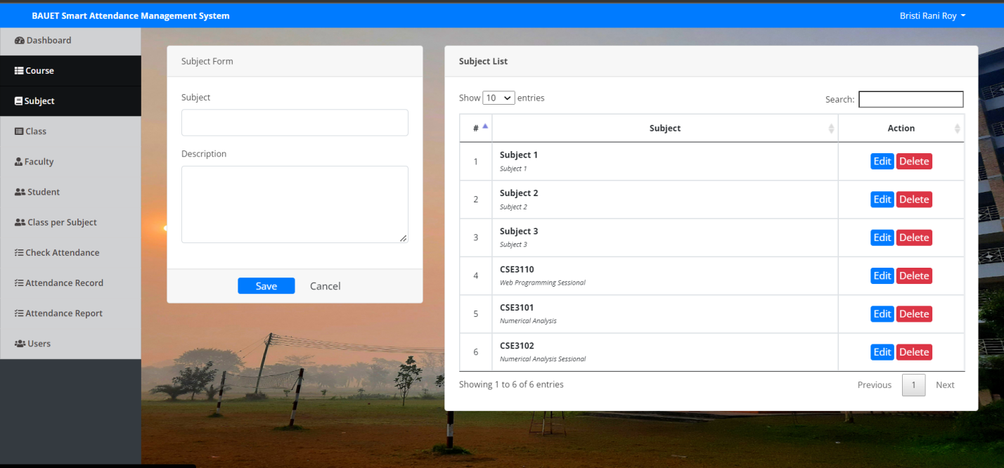

**Figure-09:** Add Subject

Here Admin can add Subject. Admin can access the subject and fill up the form for new

subjects And beside he can see the subject list.

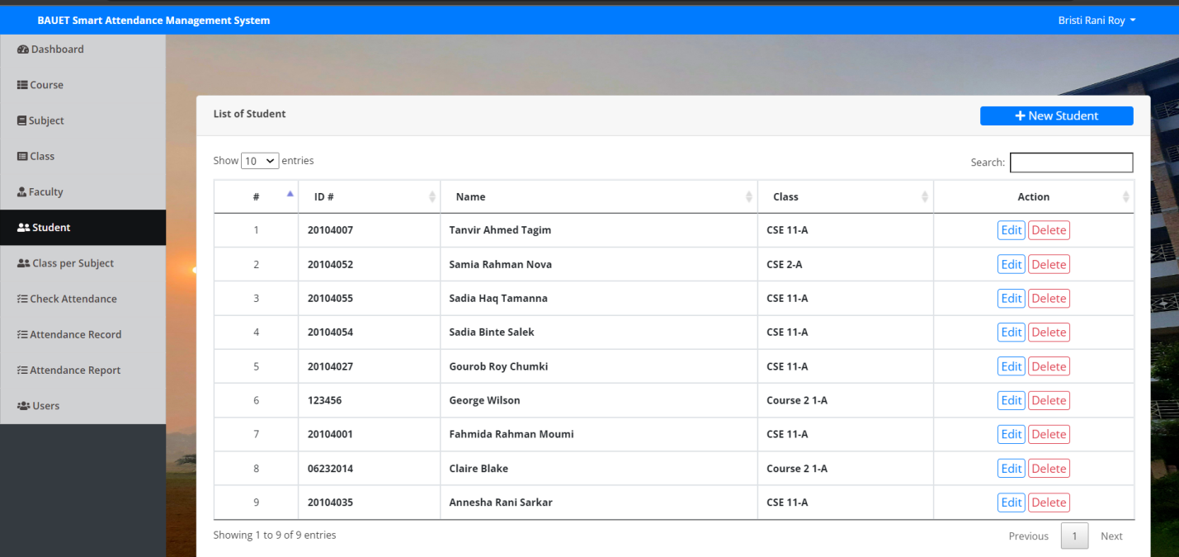**Figure-10:** Add Student

Here Admin can add Student. Admin can see the student and fillip the form for new students.

Assign the classes for student.

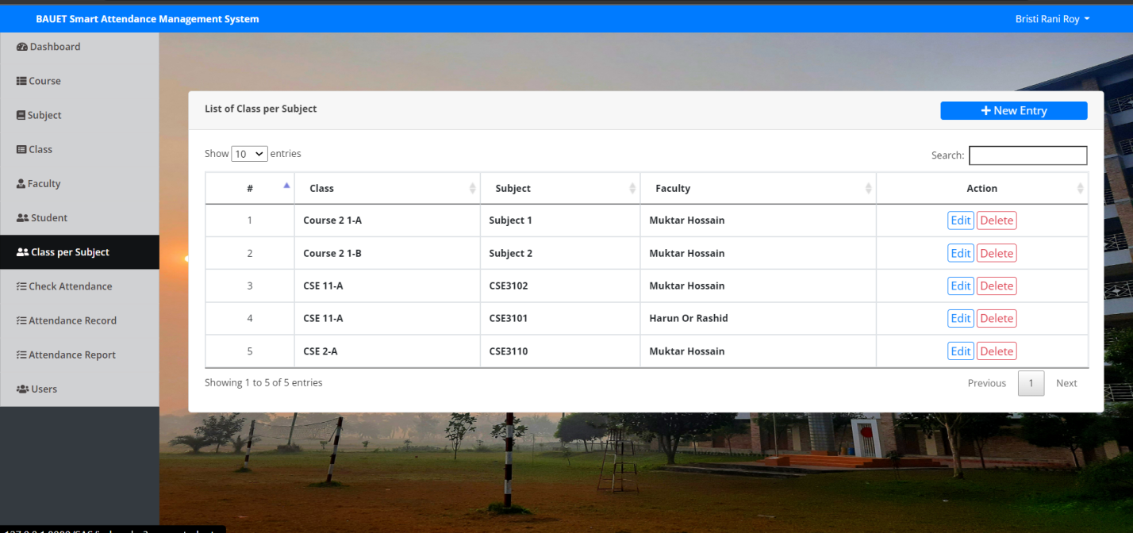

**Figure-11:** Class per Subject.

Here Admin can add Subject. Admin can access the subject and fillip the form for new

subjects And beside he can see the subject list.

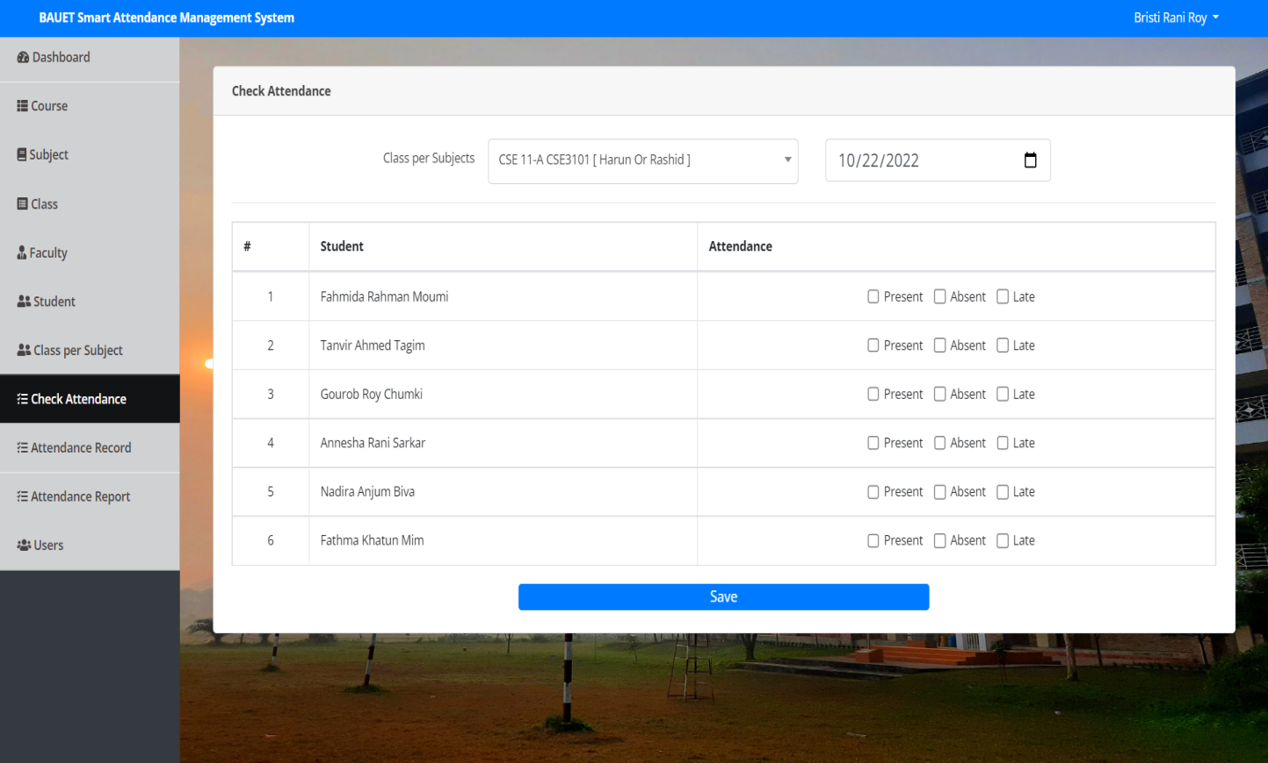 **Figure-12:** Check Attendance.

Here teacher can take attendance where we know which student is absent and which one is present or late.

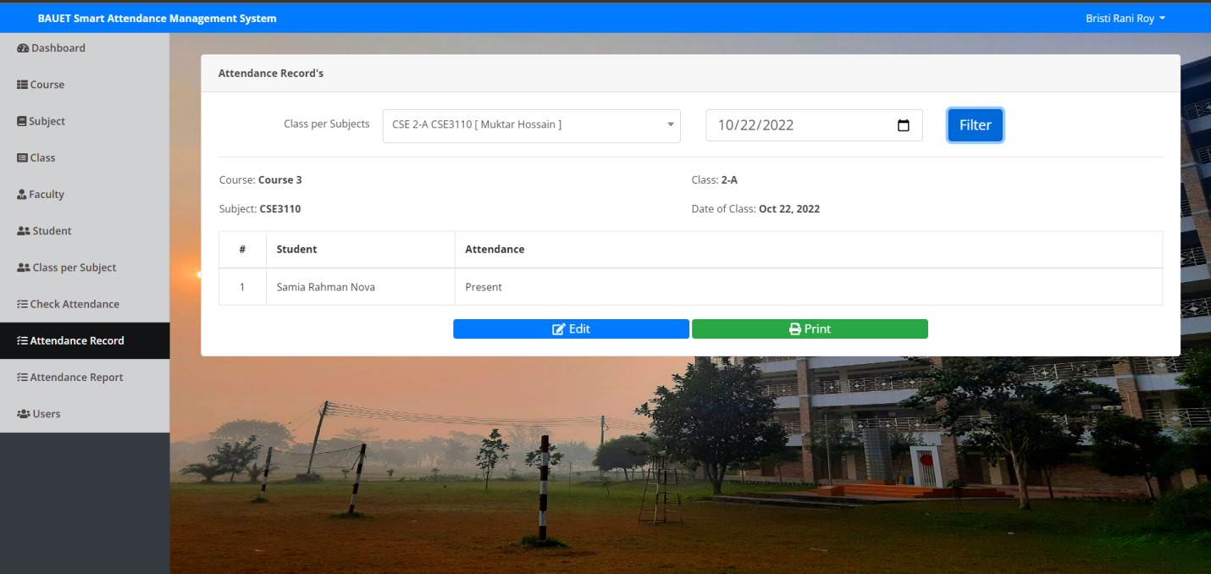

**Figure-13:** Attendance Record.

Here teacher can see the attendance record which student are absent and present.

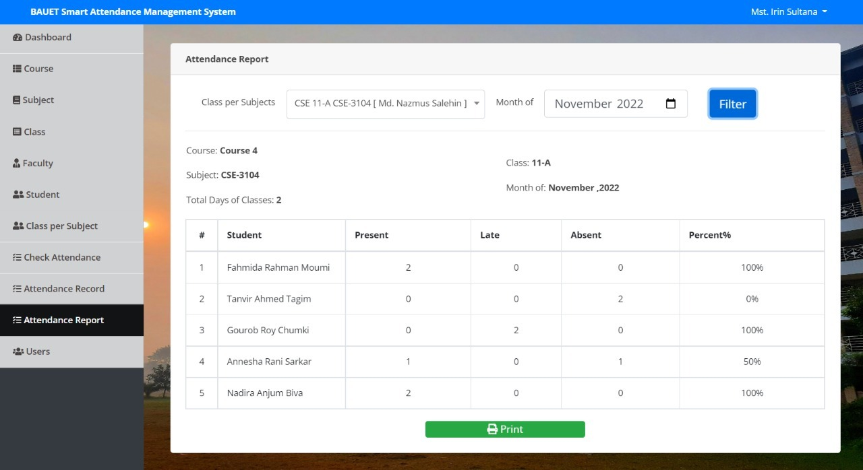

**Figure-14:** Attendance Report.

Here teacher can see the attendance record which student are absent and present.The student’s attendance reports based on weekly and consolidate will be generated.

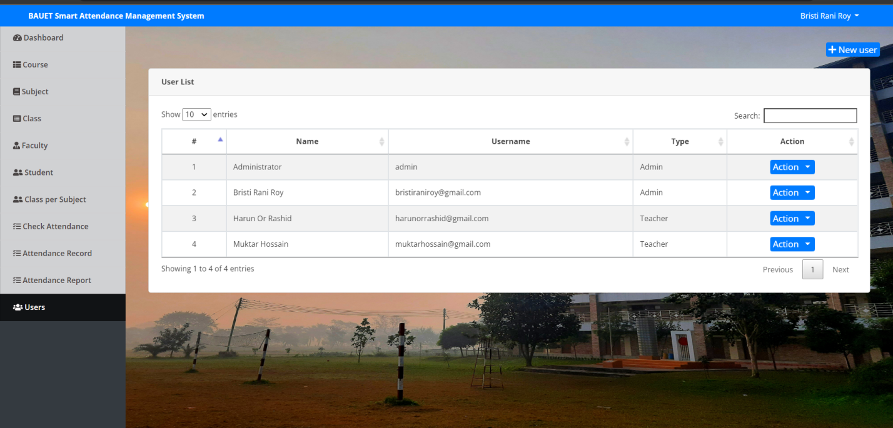

**Figure-15:** Users List

Here you can see the who is admin who is teacher. Who can access the process. We can see all user list.

**5.3 Conclusion**

A good and efficient attendance system helps in monitoring the punctuality of employees and managing the absence of people. A smart attendance system enables setting up the attendance workflows and maintaining a proper validation of employee time-sheets. An automatic attendance management system provides accurate time tracking, which helps to minimize the costly and inevitable errors in the manual data entry processes. This kind of accurate data helps provide accurate payroll and performance data.

**Chapter 6**

**Testing**

**6.1 Introduction**

Black box testing involves testing a system with no prior knowledge of its internal workings. A tester provides an input, and observes the output generated by the system under test.[6] Black box testing is a software testing methodology in which the tester analyzes the functionality of an application without a thorough knowledge of its internal design. Conversely, in white box testing, the tester is knowledgeable of the internal design of the application and analyzes it during testing. Black box testing can be used to test for functional and non-functional system requirements, though the majority of black box testing focuses on functional requirements. Black box testing is used during Unit, Integration, System, and Acceptance testing. Black-box testing is so-called because it treats the system under test as a black-box.[7] The name comes from engineering, where a black-box is a system that takes a set of defined inputs and transforms them into defined outputs. You have no idea what is going on inside the system.

**6.2 Black Box Testing**

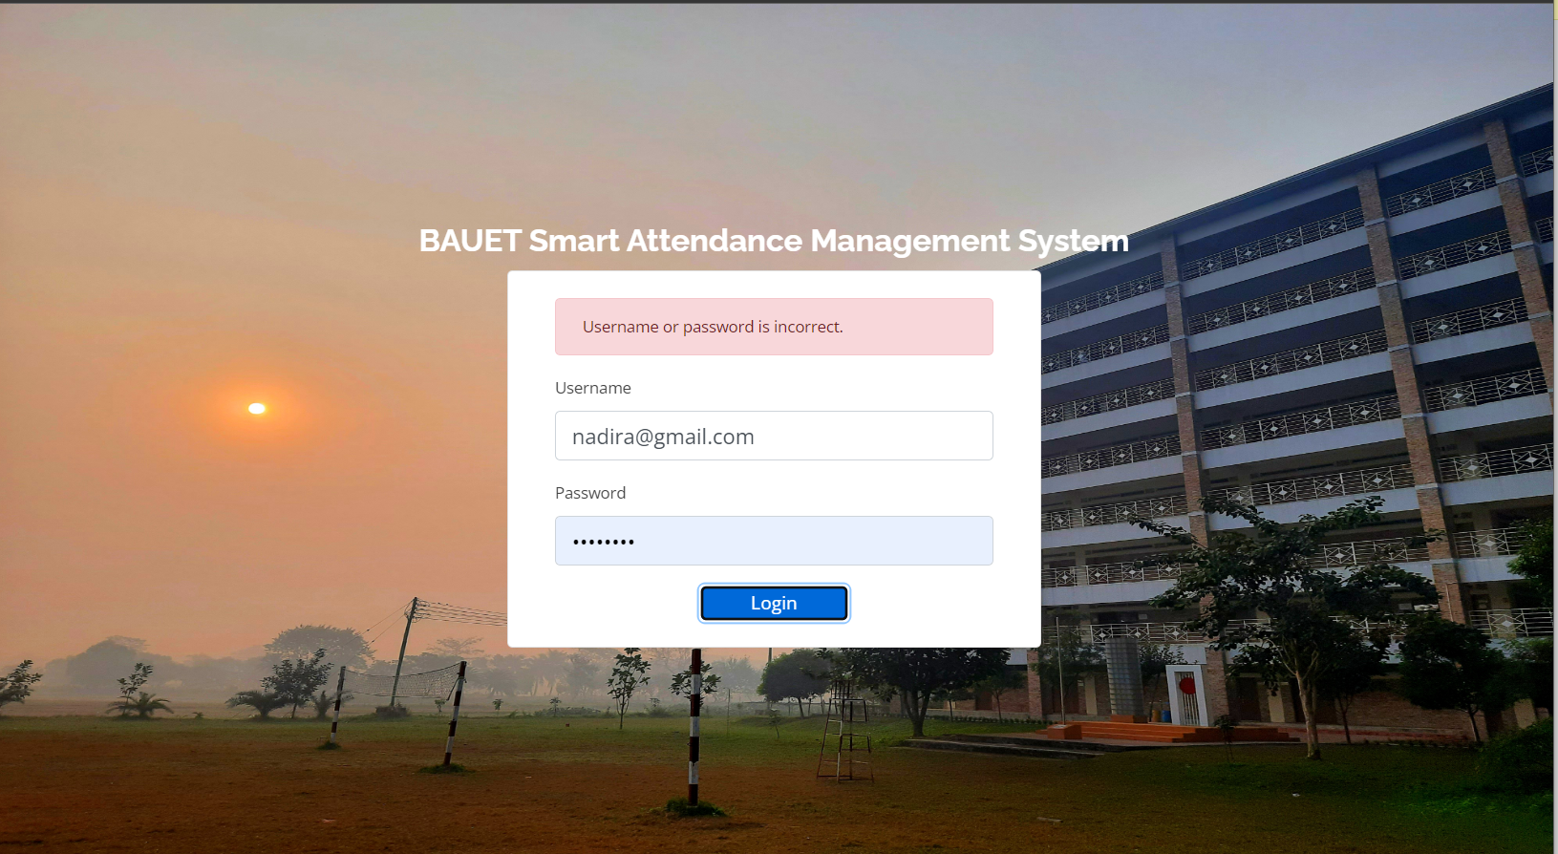

**Figure-16:** Wrong Email for login page

Wrong email won't signup even if email is correct but password doesn't match signup won't happen.

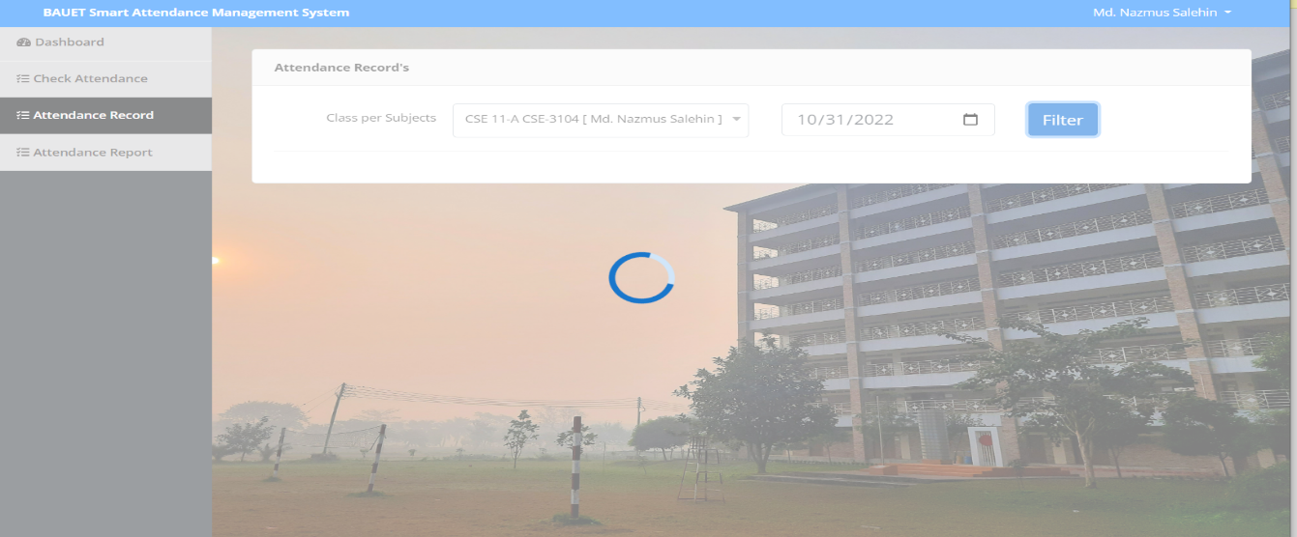

**Figure- 17:** Output student record selected wrong date

Student recording will not show our result if we enter wrong date.

**6.2 White Box Testing:**

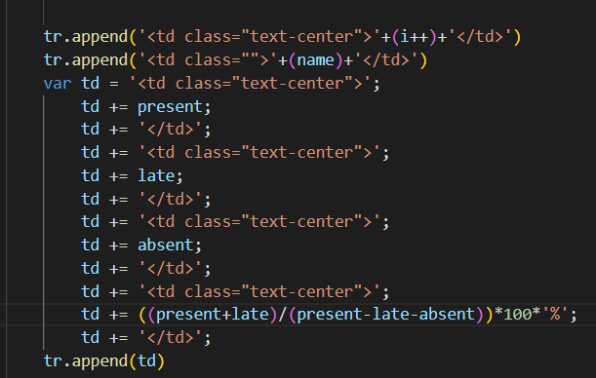

**Figure- 18:** Wrong Percentage equation in the code

If the coding percentage equation is given incorrectly, the percentage will not show.

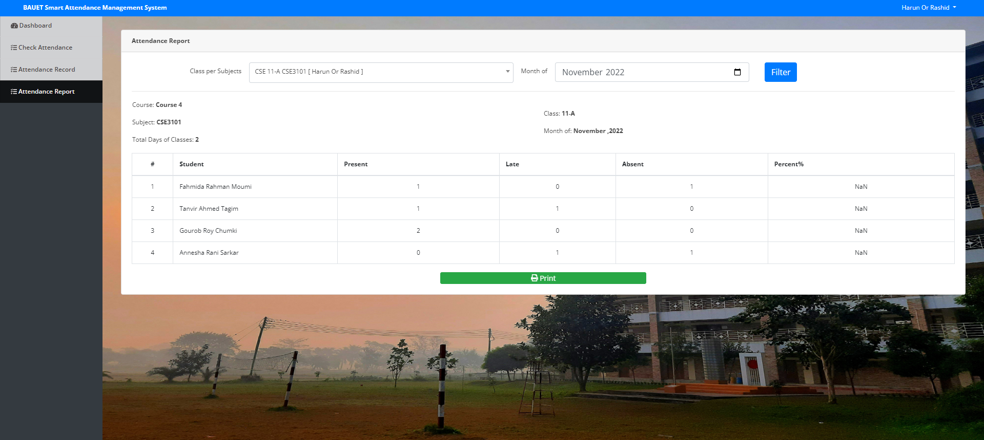

**Figure- 19:** output Wrong Percentage

If the coding percentage equation is given incorrectly, the percentage will not show. This is our output when percentage equation is wrong then show the nan.

**6.4 Conclusion**

A black box is an electronic recording device placed in an aircraft to facilitate the investigation of aviation accidents and incidents. They are also known as flight recorders. White box testing is a software testing technique that tests the internal structure and coding of software to verify the input-output flow and to improve the design, usability and security of software.[5] Since the code is visible to testers, it is called a White box or Open box or Clear box testing.[6]

**Chapter 7**

**Conclusion**

**7.1 Introduction**

The proposed system is user-friendly because the retrieval and storing of data is fast and data is maintained efficiently. Moreover, the interface provided in the proposed system provides users to deal with the system very easily [5]. Reports can be easily generated in the proposed system so users can generate the report as per the requirement (weekly, monthly) or in the middle of the semester. The proposed system requires very less paperwork.[6] All the data is feted into the computer immediately and reports can be generated through computers. Moreover, work becomes very easy because there is no need to keep data on paper. [6]The existing system is not user-friendly because the retrieval of data is very slow and data is not maintained efficiently. We are building the app to recover it. We require more calculations to generate the report so it is generated at the end of the semester.[7] And the student doesn’t get a single chance to improve their Attendance. This system can automate the checking of answers which are pre-stored so that results can be generated as soon as the student gives the reason.[7] It can generate result charts as per required. Finally, it should prove costcost-effectivecompared to the current system.

**7.2 Future Scope:**

The project has a very vast scope in future. The project can be implemented on intranet in future. Project can be updated in near future as and when requirement for the same arises, as it is very flexible in terms of expansion. With the proposed software of database Space Manager ready and fully functional the client is now able to manage and hence run the entire work in a much better, accurate and error free manner. The following are the future scope for the project.

1. Discontinue of particular student eliminate potential attendance.

2. Bar code Reader based attendance system.

3. Individual Attendance system with photo using Student login.

**7.3 Conclusion:**

Student attendance system helps teachers to mark online attendance of students during class & reduce manual work. It is used to track student's attendance, absentee record, attendance history & other related documents. Student attendance software allows we to record & manage daily student attendance to speed up the daily attendance process. Tracking student attendance helps the teachers to keep track of student absenteeism and punctuality. It helps schools understand the average percentage of students attending school each day in the given year and helps them find ways to avoid dropouts. The project has a very vast scope in future. The project can be implemented on intranet in future. Project can be updated in near future as and when requirement for the same arises, as it is very flexible in terms of expansion. It’s the system used to track how much time the workers spend working and how much time they spend off. This attendance management system project report talks about all of its documentation.

**REFERENCES**

|  |  |
| --- | --- |
| [1] | “Attendance” [Available on Online] [https://www.researchgate.net/publication/303023 7](https://www.researchgate.net/publication/303023%207)39_Web-based_Attendance_Management_System, 31 July 2022 |
| [2] | “Smart Attendance” [Available on Online] <https://www.researchgate.net/>publication/ 330105832_Smart_Attendance_Management_System_SAMSYS_for_an_Academic_Institution_Email_Address, 03 August 2022 |
| [3] | “Attendance” [Available on Online]<https://www.researchgate.net/publication/33010> 5832_Smart_Attendance_Management_System_SAMSYS_for_an_Academic_Institution_Email_Address, 05 August 2022 |
| [4] | “Smart Attendance” [Available on Online] <https://www.academia.edu/7760318/>STUD ENTS_ATTENDANCE_MANAGEMENT_SYSTEM_MINI_PROJECT_REPORT_MASTER_OF_COMPUTER_APPLICATIONS, 07 August 2022 |
| [5] | “Sheet_of_Attendance” [Available on Online] https://itsourcecode.com/attendance -management-system-project-report-doc, 10 September 2022 |
| [6] | “Sheet_of_Attendance” [Available on Online] [www.bilytica.com//ttendance-manage](http://www.bilytica.com//ttendance-manage) ment-and-benefits-of-hr-payroll-and-performance-management-software-in-unitedara b-emirates, 15 October 2022 |
| [7] | “The need for smart attendance” [Available on Online] [www.advanceecomsolutions](http://www.advanceecomsolutions).c om, 25 October 2022 |